Matplotlib is a low level graph plotting library in python that serves as a visualization utility. The source code for Matplotlib is located at this github repository https://github.com/matplotlib/matplotlib
Installation CMD C:\Users\Your Name>pip install matplotlib
Once Matplotlib is installed, import it in your applications by adding the import module statement: (Python)
import matplotlib
print(matplotlib.__version__)

Most of the Matplotlib utilities lies under the pyplot submodule, and are usually imported under the plt alias:
import matplotlib.pyplot as plt # Now the Pyplot package can be referred to as plt. Example
import matplotlib.pyplot as plt
import numpy as np
xpoints = np.array([0, 6])
ypoints = np.array([0, 250])
plt.plot(xpoints, ypoints)
plt.show()
Result
#Two lines to make our compiler able to draw:
plt.savefig(sys.stdout.buffer)
sys.stdout.flush()

Plotting x and y points. The plot() function is used to draw points (markers) in a diagram. By default the plot(), function draws a line from point to point. The function takes parameters for specifying points in the diagram.
Parameter 1 is an array (the points on the x-axis). Parameter 2 is an array containing the points on the y-axis. If we need to plot a line from (1, 3) to (8, 10), we have to pass two arrays [1, 8] and [3, 10] to the plot function.

Plotting Without Line. To plot only the markers, you can use shortcut string notation parameter 'o', which means 'rings'. Three lines to make our compiler able to draw:
import sys
import matplotlib
matplotlib.use('Agg')

import matplotlib.pyplot as plt
import numpy as np
xpoints = np.array([1, 8])
ypoints = np.array([3, 10])
plt.plot(xpoints, ypoints, 'o')
plt.show()
#Two lines to make our compiler able to draw:
plt.savefig(sys.stdout.buffer)
sys.stdout.flush()

Multiple Points You can plot as many points as you like, just make sure you have the same number of points in both axis. #Three lines to make our compiler able to draw:
import sys
import matplotlib
matplotlib.use('Agg')
import matplotlib.pyplot as plt
import numpy as np
xpoints = np.array([1, 2, 6, 8])
ypoints = np.array([3, 8, 1, 10])
plt.plot(xpoints, ypoints)
plt.show()
#Two lines to make our compiler able to draw:
plt.savefig(sys.stdout.buffer)
sys.stdout.flush()

Default X-Points
If we do not specify the points on the x-axis, they will get the default values 0, 1, 2, 3 (etc., depending on the length of the y-points. So, if we take the same example as above, and leave out the x-points, the diagram will look like this:
#Three lines to make our compiler able to draw:
import sys
import matplotlib
matplotlib.use('Agg')
import matplotlib.pyplot as plt
import numpy as np
ypoints = np.array([3, 8, 1, 10, 5, 7])
plt.plot(ypoints)
plt.show()
#Two lines to make our compiler able to draw:
plt.savefig(sys.stdout.buffer)
sys.stdout.flush()

Markers. Use the keyword argument marker to emphasize each point with a specified marker:
#Three lines to make our compiler able to draw:
import sys
import matplotlib
matplotlib.use('Agg')
import matplotlib.pyplot as plt
import numpy as np
ypoints = np.array([3, 8, 1, 10])
plt.plot(ypoints, marker = 'o')
plt.show()
#Two lines to make our compiler able to draw:
plt.savefig(sys.stdout.buffer)
sys.stdout.flush()

Create Histogram. In Matplotlib, we use the hist() function to create histograms. Uuse an array of numbers to create a histogram, the array is sent into the function as an argument. For simplicity we use NumPy to randomly generate an array with 250 values, where the values will concentrate around 170, and the standard deviation is 10. Learn more about Normal Data Distribution in our Machine Learning Tutorial.
import matplotlib.pyplot as plt
import numpy as np
x = np.random.normal(170, 10, 250)
plt.hist(x)
plt.show()
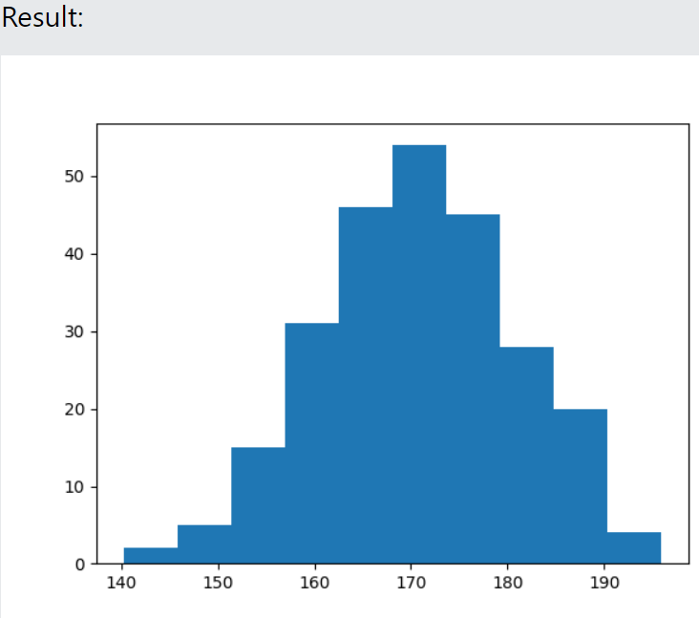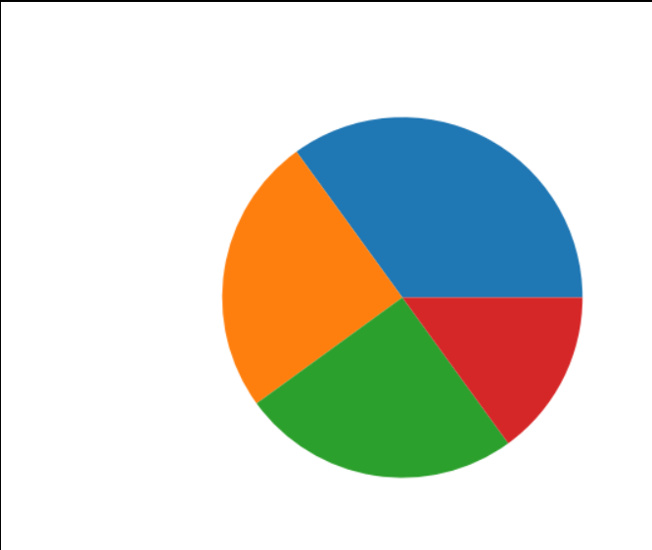
PIE chart. #Three lines to make our compiler able to draw:
x
Prueba de Tukey
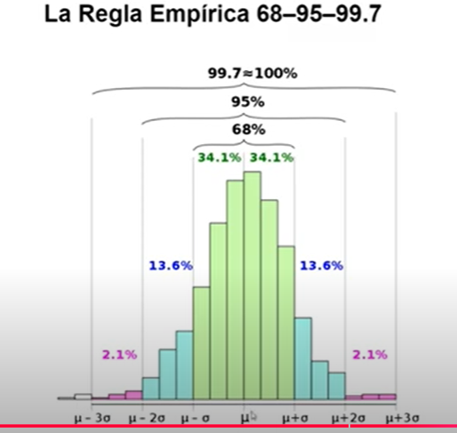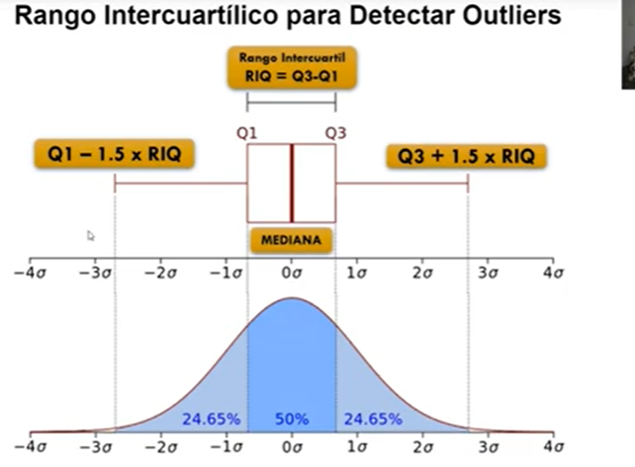

https://github.com/mwaskom/seaborn-data/blob/master/penguins.csv

